Soulslike game in Unity – Daniel Trandafir

Sprint 4 Realisation

Table of Contents

**Introduction** 1

**Lock-on system** 1

**I.** **Player Camera Script** 2

**II.** **Player Input Manager Script** 4

**Directional Based Damage Animations & UI** 5

**Creating AI** 5

**AI State** 6

**AI Character** 10

**Conclusion** 11

# **Introduction**

The purpose of this document is to provide a more detailed analysis of the progress I made with my personal project during the fourth sprint. In this phase of my project, I focused mostly on the lock-on system, allowing the player to lock-on a target enemy, which enables strafing movement and makes attacking easier. Alongside this, I added an enemy AI skeleton, that uses different states to determine what action it should take, such as being idle, chasing the player, or attacking. Thus, in this report I will go into more depth into these features I implemented and showcase them visually. As the semester is coming to a close, I have decided that this will be my last report, since I will shift my focus to working on the group project instead.

# **Lock-on system**

The lock-on system is yet another staple of the Souls series. It allows the player to “lock-on” a certain enemy, which makes the camera focus on said enemy, enabling strafing movement for the player and making attacking and dodging easier. Implementing such a system didn’t prove to be very difficult in my project. It involved quite a bit of camera manipulation and math, but I am proud to say I did not encounter almost any bugs while working on the code for this system. Most of the additions were made in scripts that already exist, such as PlayerCamera and PlayerInputManager, but I also created a WorldUtilityManager which, based on its name, has uses outside of the lock-on calculations as well.

## **Player Camera Script**

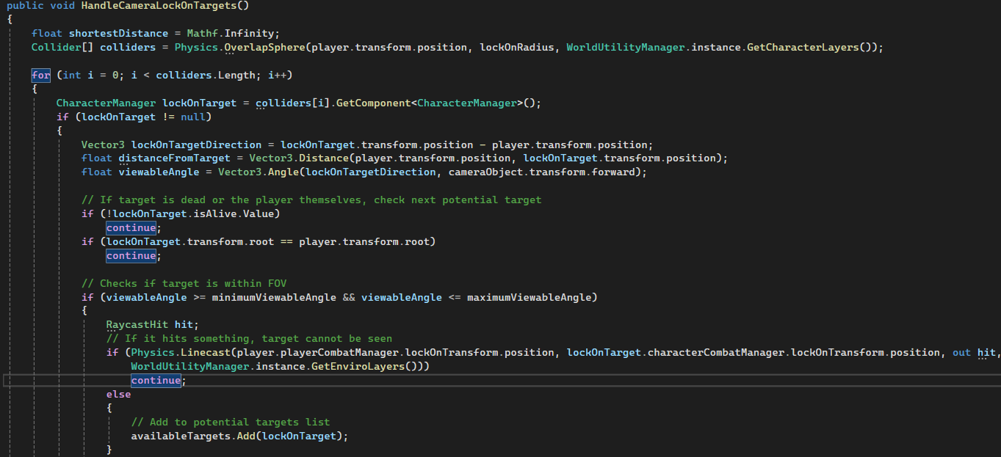

Image 01 – First part of **HandleCameraLockOnTarget()**

* The first addition to this script is the **HandleCameraLockOnTarget()** method. The purpose of this method is to first add possible lock on targets to a list and then, based on the shortest distance to the player, determine which one to set as the current lock on target, since a player can’t lock on multiple targets at once.
* It first grabs a list of colliders that are part of the character layer, namely “Character” and “Damageable Character”, which I created myself. After performing a few safety checks, it verifies whether the target is within the Line of Sight of the player and if so, adds it to a list of potential targets.

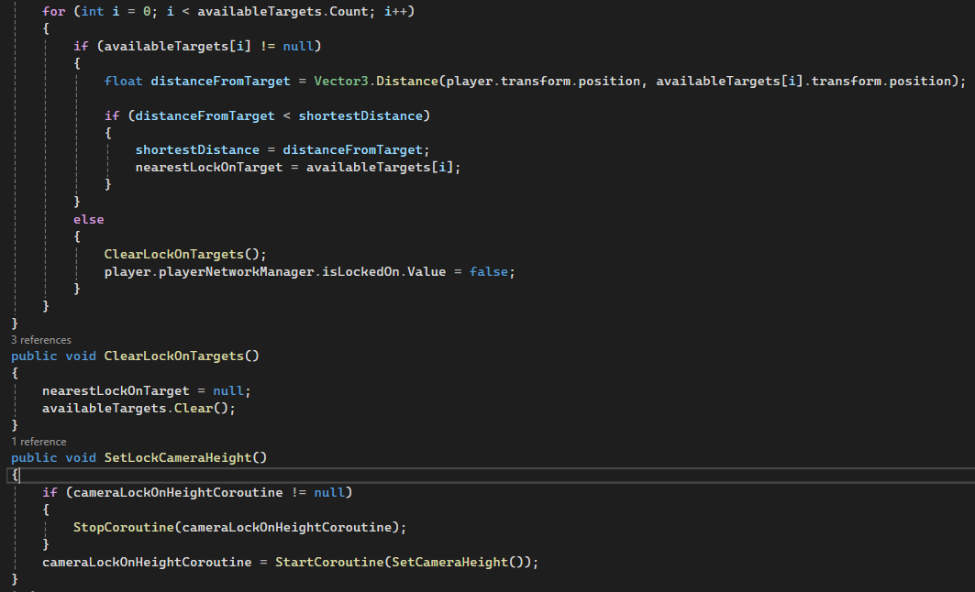

Image 02 – Second part of **HandleCameraLockOnTarget(),** together with **ClearLockOnTargets()** and **SetLockCameraHeight()**

* The second half of the method goes through the list of available targets and chooses the nearest lock-on target based on the shortest distance from the player themselves. If no target can be found, it clears the list and sets the nearest lock-on target to null in **ClearLockOnTargets().**
* **SetLockOnCameraHeight()** is called from a method in a different script, the PlayerCombatManager, which in turn is called from the PlayerInputManager when the player presses middle-mouse to begin the lock-on interaction. It simply starts a coroutine which I will cover next.

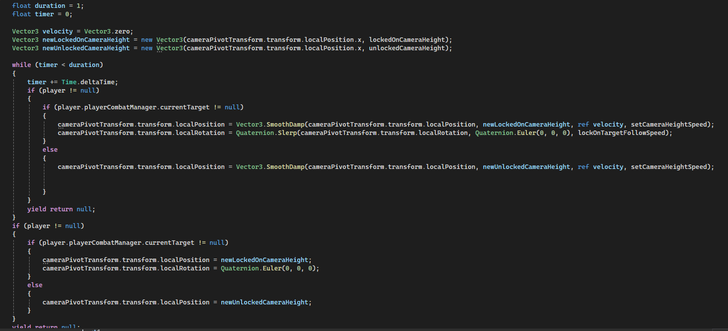

Image 03 – **SetCameraHeight()** coroutine

* This coroutine sets the camera’s position and rotation relative to the locked-on target. If the player moves, the camera will stay at a certain height and follow the locked-on target’s position.

I will now cover the changes I made to PlayerInputManager, where the methods I just covered are being called from.

## **Player Input Manager Script**

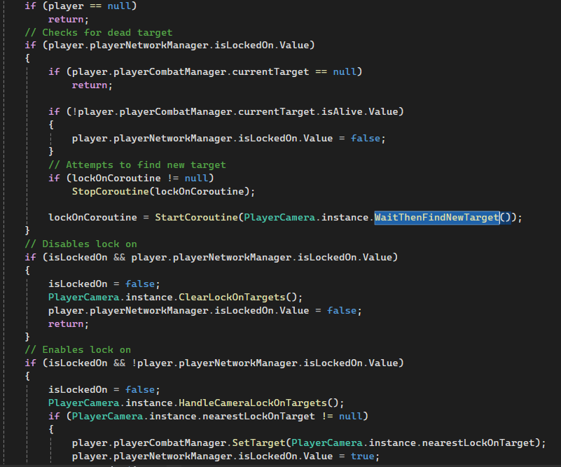

Image 04 – **HandleLockOnInput()** method

* This method first performs preliminary checks for safety, such as disabling lock-on if the player is dead, or the target is dead. Once those are done, it calls the previously discussed **HandleCameraLockOnTargets**() method and **SetTarget**(), which calls **SetCameraHeight().**



Video 01 – Lock-on system demonstration

# **Directional Based Damage Animations & UI**

This was a relatively minor addition, but a very important one. I added a Soulslike D-Pad UI to the bottom left of the screen which showcases the player’s equipped weapons. The top and bottom slots are supposed to be for magic and useable items, respectively. Also, I implemented the directional based damage animations from the animation assets I downloaded to the player character, meaning the character plays a different animation based on the direction it gets hit from. I will not cover the code I wrote for this, as it is very simple and I would rather expand upon the more complex systems I designed.



Video 02 – Directional based damage animations & UI demonstration

# **Creating AI**

Unlike everything I’ve covered in this report so far, creating AI for my game was something completely new to me, and I had no idea where to even begin. I faced many bugs, some of which I wasn’t able to resolve completely, but I did manage to make everything functional in the end.

Essentially, I have created AI State Scripts, which handle what action the AI character should take on every single tick, whether it is being idle, chasing the player, or attacking. It is also important to note I used Unity’s Navmesh Agent to allow the AI character to navigate the scene using navigation meshes that I created from the scene geometry.

I had to create a lot of new functionalities to successfully implement AI into my game. Therefore, I will only cover the most essential parts of my code in this report.

## **AI State**

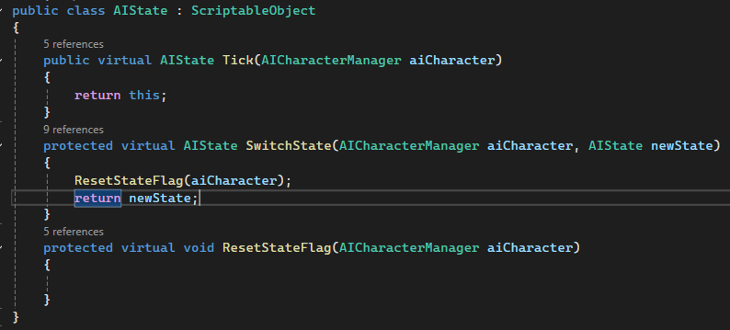

Image 05 – **AI State** Base Class

* AI State is the base scriptable object class from that all other states inherit from. It has 3 virtual methods that get overridden, but the most important one is Tick(), which returns the class itself, which will be important later.
* All the states are created as scriptable objects data containers and get added to the serializable fields in the **AICharacterManager** script in the inspector.

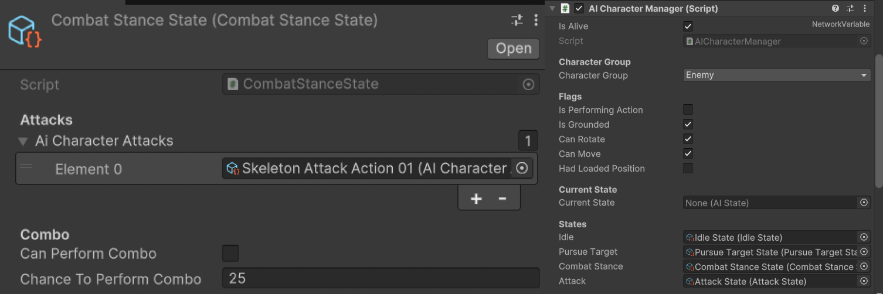

Image 06 – **Combat Stance State** and **AI Character Manager** script in the inspector

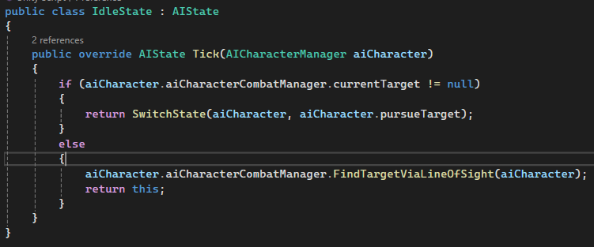

Image 07 – **Idle State** Class

* Idle state is the state in which the AI is in if the player is not within line of sight. Currently, this has the AI standing still and playing an idle animation. When the method **FindTargetViaLineOfSight()** detects the player, it will switch to the Pursue Target State.
* It can also be observed I created an AICharacterCombatManager script. I did this for most of the scripts attached to the AI prefab because AI has different behaviour and different rules apply to it compared to the player.

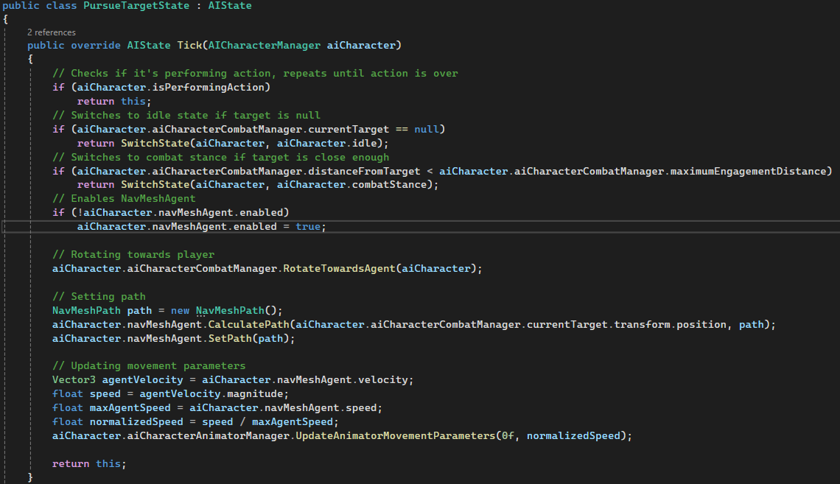

Image 08 – **Pursue Target State** Class

* This is the state the AI switches to if the player is within line of sight. It calculates the path to the player and sets it using the Navmesh Agent. Then, it moves the skeleton towards the player using virtually the same method as the player.
* If the AI character gets within range of the player, it switches to **Combat Stance State Class.**

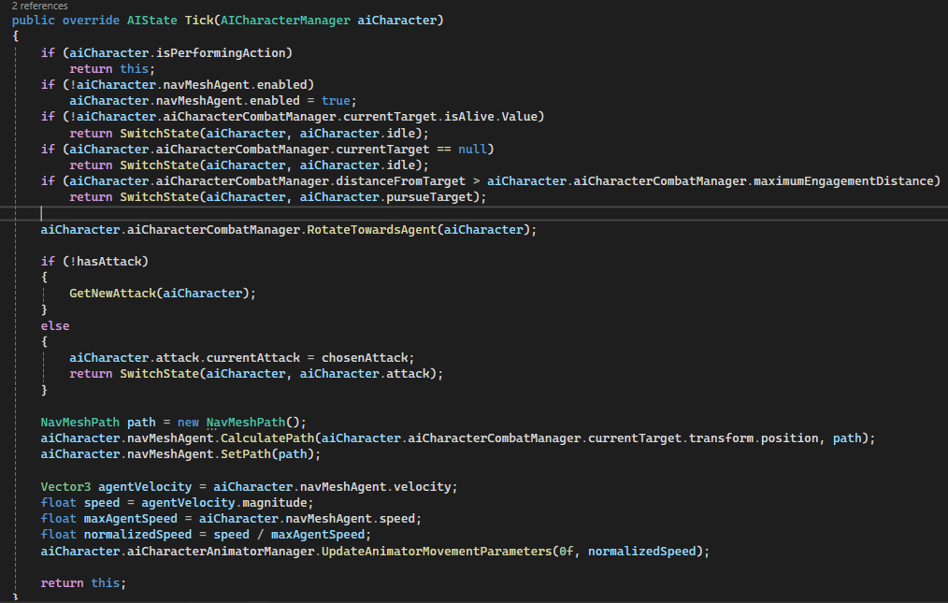

Image 09 – First half of the **Combat Stance State** class

* AI characters can have multiple types of attacks in their arsenal. I implemented the logic for this by having a separate GetNewAttack() method that has the AI Character pick an attack from a list based on its weight (significance).
* Logic for moving the character also needs to be present here, as even though the character is within range to attack the player, it still needs to be able to move.
* Once its within range and the AI has chosen an attack, it switches to the Attack State, the last AI state I implemented in this development phase.

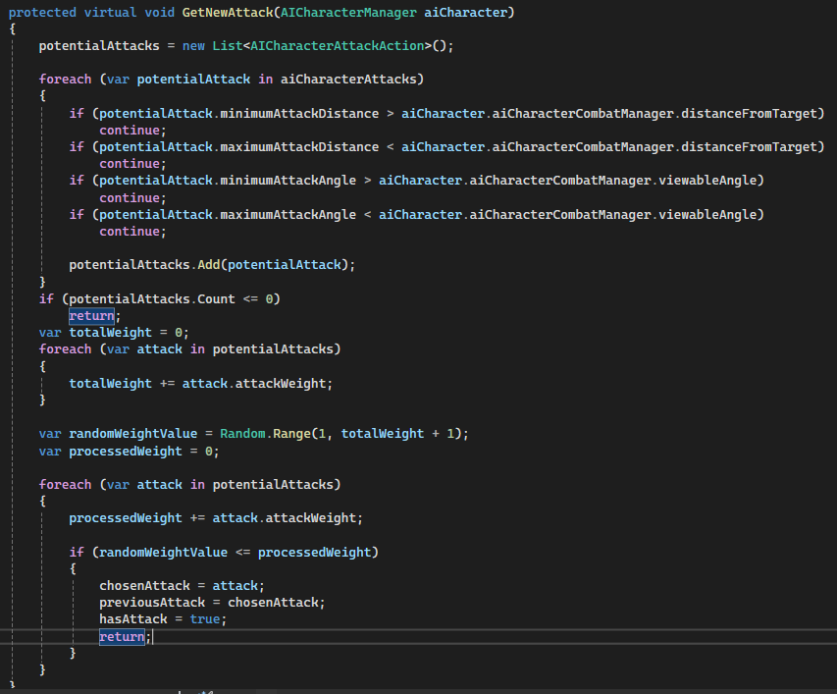

Image 10 – Second half of **Combat Stance State** class

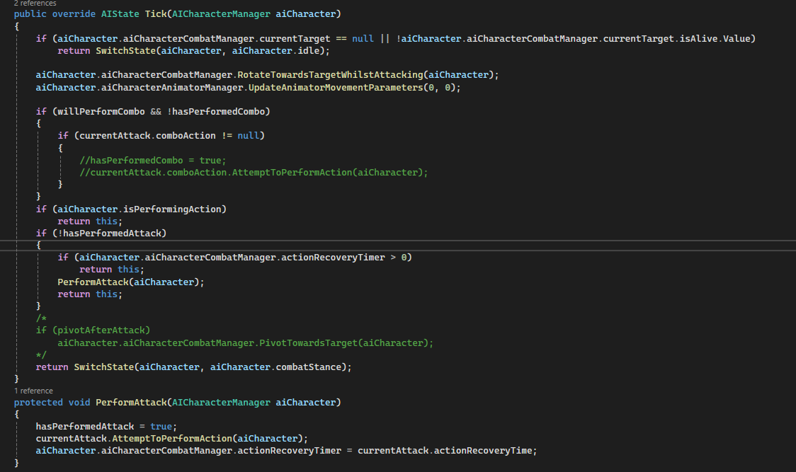

Image 11 – **Attack State** Class

* This state has the simple purpose of calling AttemptToPerformAction() if certain safety checks are passed. This is the same method that the player uses to attack using their sword.
* Also important to note is that the AI character will rotate towards the player when attacking, and that there is some logic for performing attack combos which I have yet to fully implement.

## **AI Character**

* All this logic is attached to my Skeleton AI prefab which I downloaded from the Unity Asset Store. I had to create its colliders for the sword and the skeleton’s body myself, just like I did for the player and their weapon.
* I also had to create a separate animator for the skeleton, because its animations have almost nothing in common with the player’s animations.

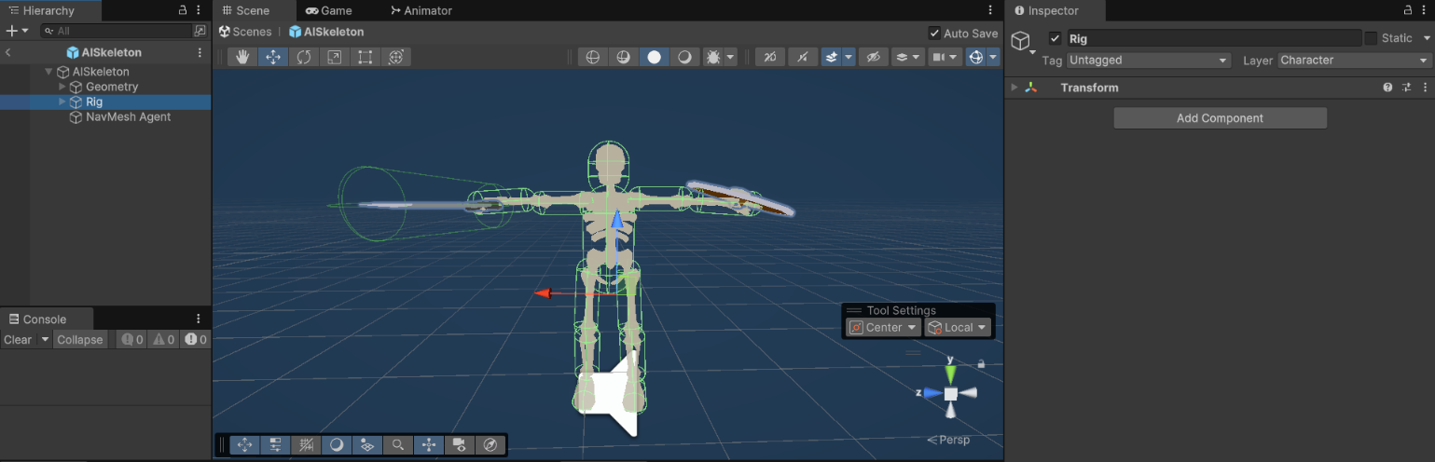

Image 12 – AI Skeleton prefab in Edit mode



Video 03 – Final AI Character Demonstration

# **Conclusion**

I am satisfied with the results I was able to achieve during this semester with my personal project. I started out knowing basically nothing about Unity and ended up learning a lot more than I thought I would be able to, and I achieved all my objectives that I set out in my project plan up to this point. Even though the AI Character is far from perfect, and it still has certain bugs, especially related to rotation, I’m proud of what I was able to achieve regardless. However, due to pressing time constraints, I will stop working on this project for now and will dedicate my time solely to the group project, where there’s a lot more that needs to be done to achieve our team’s desired goals.